Title: National Plant Monitoring Scheme - Orchids
April 2018

I have visited your property to complete plant surveys over the past three years and have been submitting my results to the scheme throughout. I noticed recently that my plant records are now included in the National Biodiversity Network (NBN) gateway having been submitted via the Suffolk Biological Records office (https://nbn.org.uk/record-share-explore-data/explore-and-use-data/). I have been surveying two woodland quadrats within your land, one within the poplar plantation which abuts Manor Road to the south of the Black Bourn river, and the second in the mixed woodland further south which is marked as '1344' in the map that you kindly sent to me in 2015. The ground flora in the poplar plantation retains an interesting diverse mix of species including several 'ancient woodland indicators' (e.g. pignut, greater stitchwort and oxlip) while the ground flora in the area of mixed woodland has been strongly dominated by dog's mercury and Arum maculatum (Lords & Ladies). I have also been surveying one linear transect along a hedgerow which is not on your land.

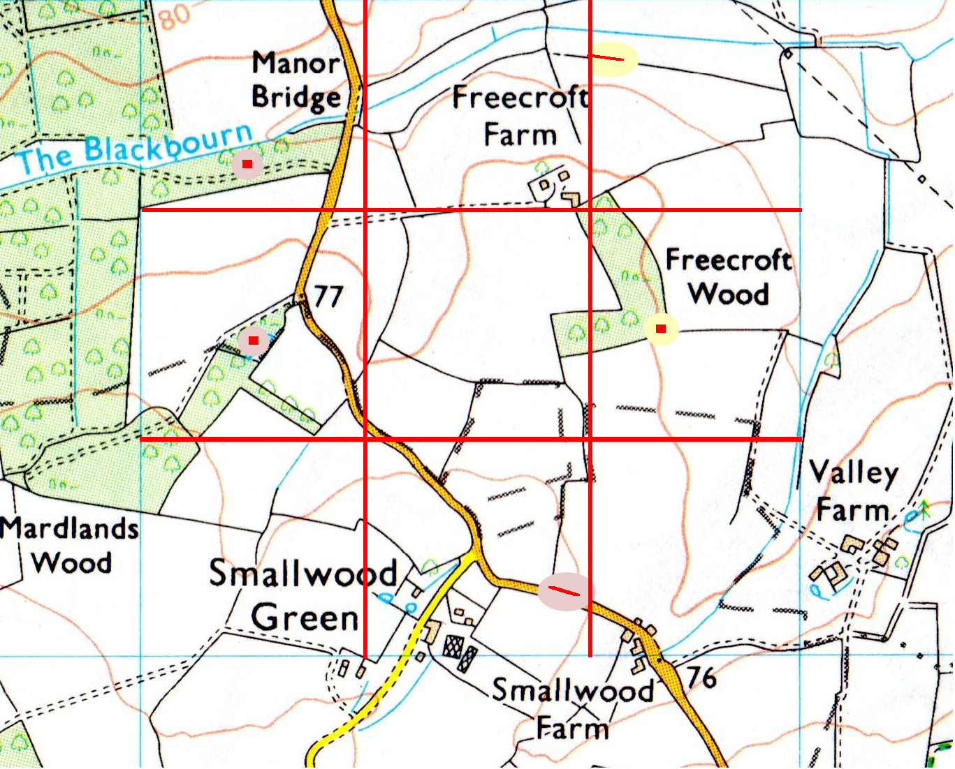

Anna Saltmarsh
ENDS
Edited by George Agnew, May 2018

